**Software Requirements**

**Specification**

**for**

**+Health**

## Version 2.0 Approved

**Prepared by:**

Cindy Torres

Ricardo Luna

Giovanni Guzmán

**09/27/19**

**Revision History**

|  |  |  |  |
| --- | --- | --- | --- |
| **Date** | **Version** | **Description** | **Author** |
| 09/27/2019 | 2.0 | Software Requirements Specification 2.0 | Ricardo Luna Cindy Torres Giovanni Guzmán |
| 09/15/2019 | 1.0 | Software Requirements Specification 1.0 | Ricardo Luna Cindy Torres Giovanni Guzmán |
|  |  |  |  |

**Table of Contents**

1. Introduction 5
   1. Purpose 5
   2. Scope 5
   3. Definitions, Acronyms and Abbreviations 6
   4. References 6
   5. Overview 6
2. Overall Description 6
   1. Use-Case Model Survey 7
   2. Assumptions and Dependencies 10
3. Specific Requirements 10
   1. Use-Case Reports 10
      1. Create an Account (Doctor) 10
      2. Login 12
      3. Modify General Information (Doctor) 13
      4. View Patient’s Medical Information 13
      5. View Patient’s Medical History 13
      6. Modify Patient’s Medical Information (Doctor) 15
      7. Create Patient’s Diagnosis 16
      8. Create Patient’s Treatment 18
      9. Download Patient’s Medical History 20
      10. Create an Account (Patient) 20
      11. View Medical Information 20
      12. View Medical History 20
      13. Modify General Information (Patient) 21
      14. Upload Medical Studies 21
      15. Request to Change Medical Information 23
      16. Grant Access to the Doctor 23
      17. Modify Patient’s Medical Information (Customer   
          Service Representative) 23
      18. Validate Doctor’s Information 23
4. **Introduction**

A Software Requirements Specification is the description of a software system to be developed. It is modeled after business requirements specification. Software requirements specification establishes the basis for an agreement between customers and contractors or suppliers on how the software product should function. The software requirements specification document lists sufficient and necessary requirements for the project development.

The aim of this document is to gather, analyze and give an in-depth insight of +Health by defining the problem statement in detail. The detailed requirements of +Health are provided in this document.

* 1. **Purpose**

The Software Requirements Specification is a communication tool between users and software designers. The specific goals of the SRS are facilitating reviews, describing the scope of work, providing a reference to software designers, providing a framework for validating use cases, including features to satisfy customer requirements, and providing a platform for ongoing maintenance.

The purpose of this document is to collect and analyze all ideas that have come up to define the system and its requirements. Also, it shall predict and sort out how the company hopes this product will be used in order to gain a better understanding of the project. Also, it pretends to document ideas that are being considered, but may be discarded as the product develops.

* 1. **Scope**

The purpose of +Health is to ease patients’ medical information management and to create a convenient and easy-to-use application for doctors, trying to have all their patients’ medical information in a handy way. Above all, it is expected for the application to provide a comfortable user experience.

* 1. **Definitions, Acronyms and Abbreviations**
* Patient’s Medical Information: Medical general information of the patient such as height, weight, chronic diseases and clinical information.
* Patient’s Medical History: Data related to a person’s medical history, including symptoms, diagnoses, procedures, and outcomes. It also includes patient histories, lab results, x-rays, and so on.
* Patient’s Code. Unique identifier that the system assigns to a patient.  
  1. **References** Analysis Model Document. (2019). 1st ed. +Health.
  2. **Overview**

The remaining sections of this document provide a general description, including characteristics of users and requirements of the product.

In section 2, it is described the general factors that affect the product and its requirements. This section does not state specific requirements. Instead, it provides a background for those requirements, which are defined in detail in Section 3, and makes them easier to understand. Includes such items as product perspective, product functions, user characteristics, constraints, assumptions and dependencies, and requirements subsets.

Section 3 contains all the software requirements to a level of detail sufficient to enable the development team to design a system to satisfy those requirements. These requirements are captured in the use cases and the applicable supplementary specifications.

1. **Overall Description**

What is +Health? +Health is an application that pretends to gather all the patients’ medical information such as chronic diseases, medical analysis, prescriptions, treatments, diagnoses and operations.

+Health purpose is to eliminate the lack of information of a patient on their medical history by having a centralized system that: 1) is able to access medical information at any given moment. 2) give access to a third party when needed. It will give a much wider and concrete insight on a patient (speaking in medical terms).

The patient will be able to access any of their medical diagnoses and treatments, mitigating misunderstandings between the parties involved. This will also improve the verification of a diagnoses and treatments from a third party, since all the information will be presented directly through the system.

Having a centralized system with all the medical history of a patient will keep misinterpretations to a minimum.

**2.1 Use-Case Model Survey**

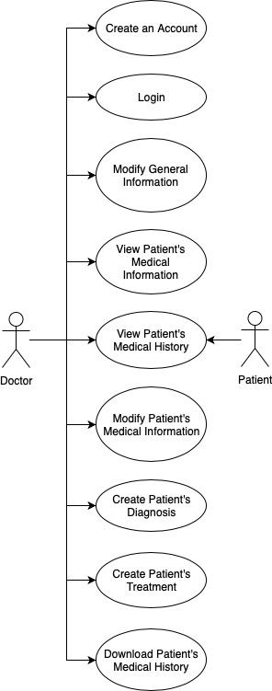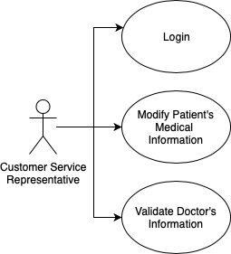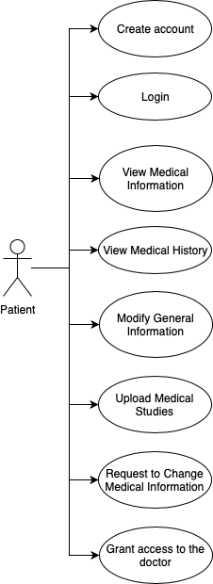

**Customer Service**

**Representative’s Use Cases**

**Patient’s Use Cases**

**Doctor’s Use Cases**

***Actors:*** An actor specifies a role played by a user or any other system that interacts with the subject. The actors involved in this project are:

* **Doctor.** This person is responsible for managing the patient’s medical information. This person is also responsible for managing their general information.
* **Patient.** This person is responsible for managing their general information.
* **Customer Service Representative.** This person is responsible for modifying concrete patient’s medical information. This person is also responsible of verifying and approving the doctor’s certificate.

***Brief descriptions:***

* **Create an Account.**This use case allows the doctor to create an account in the system. The doctor will fill out their general information and in order to validate the account use the application, the doctor needs to upload a document verifying their medical degree.
* **Login.**This case allows the doctor, the patient and the customer service representative to log into the system with their username and password.
* **Modify General Information.** This use case allows the doctor to modify their general information such as field, email and medical degree.
* **View Patient’s Medical Information.** This use case allows the doctor to view the medical information of the patient after being given access by them.
* **View Patient’s Medical History.**This use case allows the doctor to access the patient’s medical history after being given access by them. The system retrieves the patient’s medical history and displays it to the doctor.
* **Modify Patient’s Medical Information.** This use case allows the doctorto change the medical information of the patient after being given access by them. This information will be reflected in the patient’s medical history.
* **Create Patient’s Diagnosis.**This use case allows the doctor to create and fill a new diagnosis document for the patient. Once finished, the diagnosis document will be saved in the patient’s medical history.
* **Create Patient’s Treatment.**This use case allows the doctor to create and fill a new treatment document for the patient. Once finished, the treatment document will be saved in the patient’s medical history.
* **Download Patient’s Medical History.** This use case allowsthe doctor to download the complete medical history of the patient after being given access by the patient. The doctor is able to apply a filter to choose a specific time frame to be retrieved.
* **Create an Account.** This use case allows the patient to create a new account on the system. The patient must fill out his general information.
* **View Medical Information.** This use case allows the patient to view his entire medical information.
* **View Medical History.** This use case allows the patient to view his entire medical history. The patient must be able to apply a filter to choose a specific time frame to be displayed.
* **Modify General Information.** This use case allows the patient to change, add or delete general information to their profile.
* **Upload Medical Studies.**This use case allowsthe patient to upload their medical studies. The medical studies will be saved in the patient’s medical history.
* **Request to Change Medical Information.** This use case allows the patient to send a request to the system to apply a change to his medical information. The patient will be able to track the status of this request.
* **Grant Access to the Doctor.** This use case allows the patient to grant access to the doctor to view and modify their medical information and/or medical history. The patient is able to view the information of the doctor that accessed their account, and the modifications done by the doctor to their medical information.
* **Modify Patient’s Medical Information.** This use case allows the customer service representative to modify or update the information requested by the patient, so the information shown is correct.
* **Validate Doctor’s Information.** This use case allows the customer service representative to see the requests and the information attached to them from all the doctors. The customer service representative is able to update the status of the request, add feedback or ask for clarification.

**2.2 Assumptions and Dependencies**

This system does not have any kind of dependencies.

1. **Specific Requirements**

This section contains the requirements of +Health. These requirements are organized by the features discussed in the Overall Description section. Features are then represented into use case diagrams to best capture the what the system shall do.

* 1. **Use-Case Reports**

**3.1.1 Create an Account**

**Brief Description**

This use case allows the doctor to create an account in the system. The doctor will fill out their general information and in order to validate the account and use the application, the doctor needs to upload a document verifying their medical degree.

**Actors**

1. Primary Actor – Doctor

**Flow of events**

1. ***Basic Flow***
   1. ENTER ACCOUNT/PERSONAL INFORMATION

This use case starts when the doctor selects “Create an account”. The system asks for their account information such as name, email and password, and also for their personal information such as full name, age, sex, college

career, medical speciality and years of experience. The doctor enters the data and selects “Continue”.

* 1. VALIDATE GENERAL INFORMATION

The system validates the doctor’s information by checking if all the corresponding fields are correctly filled.

* 1. UPLOAD MEDICAL CERTIFICATION DEGREE

The system asks for a Medical Certification Degree. The doctor shall upload their Medical Certification Degree (a document that shows their permission to work as a doctor).

* 1. VALIDATE MEDICAL CERTIFICATION DEGREE

The system validates the doctor’s Medical Certification Degree by checking if a document is attached.

* 1. COMPLETE REGISTRATION

The doctor’s information is stored in their account. The system shows the message “Account created successfully”. The use case ends.

1. ***Alternative Flow***
   1. QUIT

+Health allows the doctor to quit at any time during this use case. No information is saved. The use case ends.

* 1. MISSING INFORMATION

At BF VALIDATE GENERAL INFORMATION, the system determines the information for the creation of a new account is not sufficient. The system displays a “Missing information” message. The use case resumes at BF ENTER ACCOUNT/PERSONAL INFORMATION.

* 1. WRONG INFORMATION

At BF VALIDATE GENERAL INFORMATION, the system determines the entered information values are not valid. The system displays a “Wrong information” message.  The use case resumes at BF ENTER

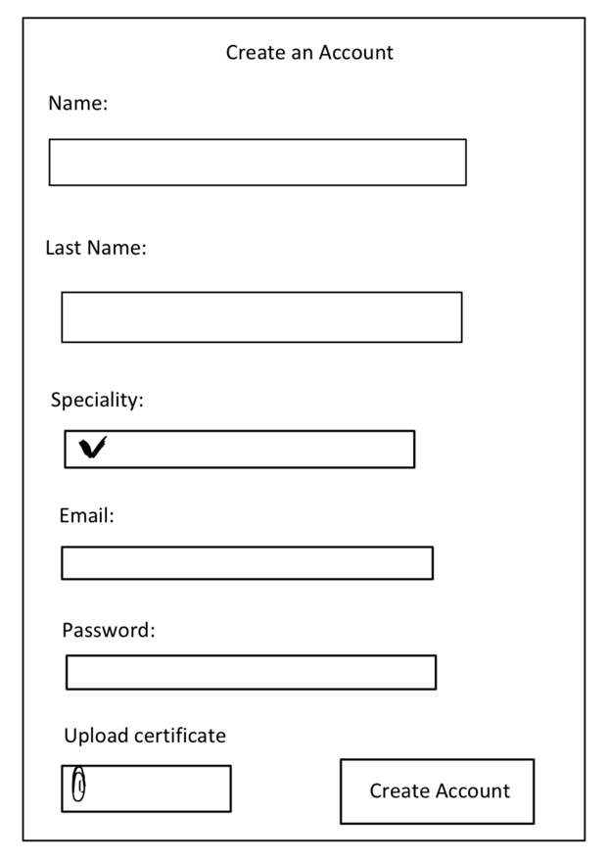

ACCOUNT/PERSONAL INFORMATION.

* 1. MISSING MEDICAL CERTIFICATION DEGREE

At BF VALIDATE MEDICAL CERTIFICATION DEGREE, the system determines the file is not uploaded. The system displays a “Missing certification” message. The use case resumes at BF UPLOAD MEDICAL CERTIFICATION DEGREE.

**3.1.2 Login**

**Brief Description**

This case allows the doctor, the patient or the customer service representative to log into the system with their username and password.

**Actors**

1. Primary Actor – Doctor
2. Primary Actor – Patient
3. Primary Actor – Customer Service Representative

**3.1.4 View Patient’s Medical Information**

**Brief Description**

This use case allows the doctor to view the medical information of the patient after being given access by them.

**Actors**

1. Primary Actor – Doctor

**3.1.3 Modify General Information**

**Brief Description**

This use case allows the doctor to modify their general information such as field, email and medical degree.

**Actors**

1. Primary Actor – Doctor
   * 1. **View Patient’s Medical History**

**Brief Description**

This use case allows the doctor to access the patient’s medical history after being given access by them. The system retrieves the patient’s medical history and displays it to the doctor.

**Actors**

1. Primary Actor – Doctor
2. Secondary Actor - Patient

**Flow of events**

1. ***Basic Flow***
   1. ENTER PATIENT’S CODE

This use case starts when the doctor enters the patient code in order to access to their medical history.

1.2 VALIDATE PATIENT’S CODE

The system shall validate that the patient’s code exists. The system retrieves the patient. The doctor should check that it is the correct patient and then select “Show patient’s information”.

1.3 GIVE ACCESS TO THE DOCTOR

The patient shall give access to their information to their doctor.

1.3 SHOW PATIENT’S GENERAL INFORMATION

The system retrieves the patient’s general information and shows it to the doctor. The doctor selects “View patient’s medical history”.

1.4 SHOW PATIENT’S MEDICAL HISTORY

The system retrieves the Patient’s Medical History. The use case ends.

1. ***Alternative Flow***
   1. QUIT

+Health allows the doctor to quit at any time during this use case. No information is saved. The use case ends.

* 1. UNKOWN PATIENT’S CODE

At BF ENTER PATIENT’S CODE, the patient does not know their code. The doctor shall quit. The use case ends.

* 1. PATIENT NOT FOUND

At BF VALIDATE PATIENT’S CODE, the system does not find the patient with the patient code. The system shows the message “No patient found”. The use case resumes at BF ENTER PATIENT’S CODE.

2.4 WRONG PATIENT

At BF VALIDATE PATIENT’S CODE, the system retrieves the information of another patient. The doctor shall quit. The use case resumes at BF ENTER PATIENT’S CODE.

2.5 MEDICAL HISTORY UNREACHEABLE

At BF SHOW PATIENT’S MEDICAL HISTORY, the system cannot

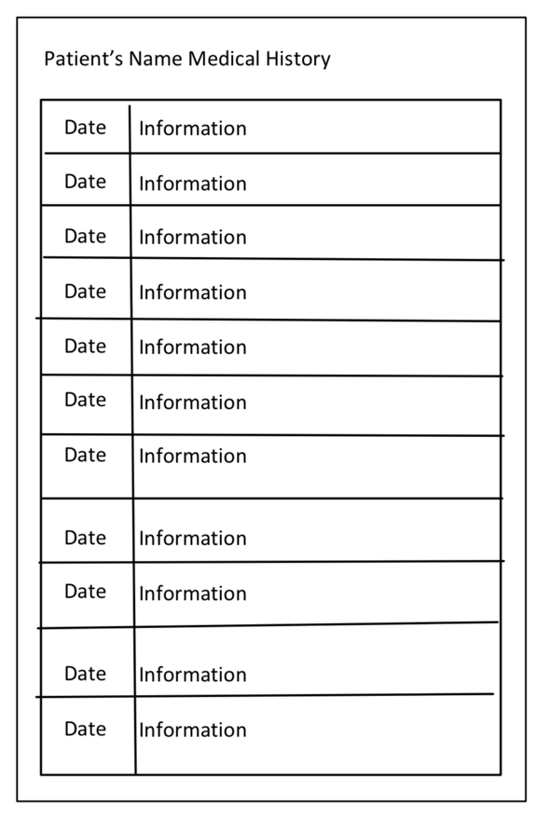

retrieve the patient’s medical history. The system shows the message “It was not possible to retrieve the patient’s medical history”. The use case resumes at BF SHOW PATIENT’S GENERAL INFORMATION.

2.6 MEDICAL HISTORY DOES NOT EXIST

At BF SHOW PATIENT’S MEDICAL HISTORY, the patient does not have a medical history. The system shows the message “There is no medical history”. The use case ends.

* + 1. **Modify Patient’s Medical Information**

**Brief Description**

This use case allows the doctorto change the medical information of the patient after being given access by them. This information will be reflected in the patient’s medical history.

**Actors**

1. Primary Actor – Doctor
   * 1. **Create Patient’s Diagnosis**

**Brief Description**

This use case allows the doctor to create and fill a new diagnosis document for the patient. Once finished, the diagnosis document will be saved in the patient’s medical history.

**Actors**

1. Primary Actor – Doctor

**Precondition**

1. The doctor must have accessed to the patient’s profile.

**Flow of events**

1. ***Basic Flow***
   1. CREATE A NEW DIAGNOSIS

This use case starts when the doctor selects “New diagnosis” in the patient’s profile.

* 1. REQUEST FOR DIAGNOSIS’ INFORMATION

The system asks for diagnosis information. This information refers to date, general observations and the patient’s diagnosis.

* 1. ENTER DIAGNOSIS’ INFORMATION

The doctor enters the diagnosis information and selects “Add diagnosis”.

* 1. VALIDATE DIAGNOSIS’ INFORMATION

The system validates the entered information by checking if all the corresponding fields are correctly filled.

* 1. CREATE DIAGNOSIS

The system attaches the diagnosis’ information to the patient’s medical history and shows the message “Diagnosis created”. The use case ends.

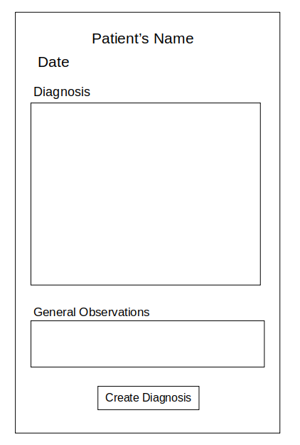

1. ***Alternative Flow***
   1. QUIT

+Health allows the doctor to quit at any time during this use case. No information is saved. The use case ends.

* 1. MISSING INFORMATION

At BF VALIDATE DIAGNOSIS’ INFORMATION, the system determines the information is incomplete. The system displays a “Missing information” message. The use case resumes at BF REQUEST FOR DIAGNOSIS’ INFORMATION.

* 1. WRONG INFORMATION

At BF VALIDATE DIAGNOSIS’ INFORMATION, the system determines the entered information values are not valid. The system displays a “Wrong information” message.  The use case resumes at BF REQUEST FOR DIAGNOSIS’ INFORMATION.

* 1. DIAGNOSIS’ CREATION FAILURE

AT BF CREATE DIAGNOSIS, the system cannot create the diagnosis. The system shows the message “Unable to create the patient’s diagnosis”. The use case resumes at BF ENTER DIAGNOSIS’ INFORMATION.

* + 1. **Create Patient’s Treatment**

**Brief Description**

This use case allows the doctor to create and fill a new treatment document for the patient. Once finished, the treatment document will be saved in the patient’s medical history.

**Actors**

1. Primary Actor – Doctor

**Precondition**

1. The doctor must have accessed to the patient’s profile.

**Flow of events**

1. ***Basic Flow***
   1. CREATE A NEW TREATMENT PRESCRIPTION

This use case starts when the doctor selects “New treatment prescription” in the patient’s profile.

* 1. REQUEST FOR PRESCRIPTION’S INFORMATION

The system asks for prescription’s information. This information refers to date, list of drugs, medicine notes and general observations.

* 1. ENTER PRESCRIPTION’S INFORMATION

The doctor enters the prescription information and select “Add prescription”.

* 1. VALIDATE PRESCRIPTION’S INFORMATION

The system validates the entered information by checking if all the corresponding fields are correctly filled.

* 1. CREATE TREATMENT PRESCRIPTION

The system attaches the prescription’s information to the patient’s medical history and shows the message ‘Prescription created”. The use case ends.

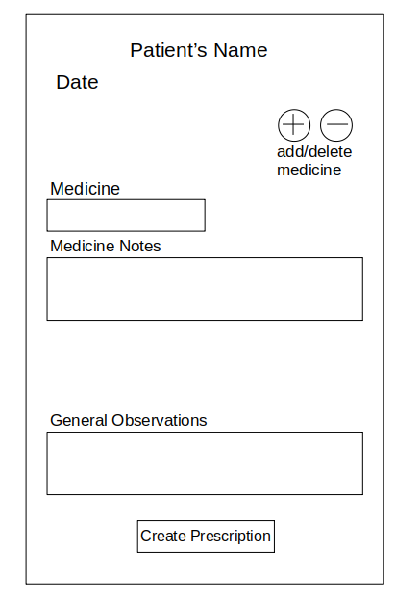

1. ***Alternative Flow***
   1. QUIT

+Health allows the doctor to quit at any time during this use case. No information is saved. The use case ends.

* 1. MISSING INFORMATION

At BF VALIDATE PRESCRIPTION’S INFORMATION, the system determines the information is incomplete. The system displays a “Missing information” message. The use case resumes at BF REQUEST FOR PRESCRIPTION’S INFORMATION.

* 1. WRONG INFORMATION

At BF VALIDATE PRESCRIPTION’S INFORMATION, the system determines the entered information values are not valid. The system displays a “Wrong information” message.  The use case resumes at BF REQUEST FOR PRESCRIPTION’S INFORMATION.

* 1. PRESCRIPTION’S CREATION FAILURE

AT BF CREATE TREATMENT PRESCRIPTION, the system cannot create the prescription. The system shows the message “Unable to create the patient’s prescription”. The use case resumes at BF ENTER PRESCRIPTION’S INFORMATION.

* + 1. **Create an Account**

**Brief Description**

This use case allows the patient to create a new account on the system. The patient must fill out his general information.

**Actors**

1. Primary Actor – Patient
   * 1. **Download Patient’s Medical History**

**Brief Description**

This use case allowsthe doctor to download the complete medical history of the patient after being given access by the patient. The doctor is able to apply a filter to choose a specific time frame to be retrieved.

**Actors**

1. Primary Actor – Doctor
   * 1. **View Medical Information**

**Brief Description**

This use case allows the patient to view his entire medical information.

**Actors**

1. Primary Actor – Patient
   * 1. **View Medical History**

**Brief Description**

This use case allows the patient to view his entire medical history. The patient must be able to apply a filter to choose a specific time frame to be displayed.

**Actors**

1. Primary Actor – Patient
   * 1. **Modify General Information**

**Brief Description**

This use case allows the patient to change, add or delete general information to their profile.

**Actors**

1. Primary Actor – Patient
   * 1. **Upload Medical Studies**

**Brief Description**

This use case allowsthe patient to upload their medical studies. The medical studies will be saved in the patient’s medical history.

**Actors**

1. Primary Actor – Patient

**Precondition**

1. The patient must have accessed their profile.

**Flow of events**

1. ***Basic Flow***
   1. UPLOAD A NEW MEDICAL STUDY

This use case starts when the patient selects “Upload medical study” in their profile.

* 1. SHOW SUPPORTED FORMATS

The system shows to the patient the supported formats to upload their

medical study.

* 1. UPLOAD MEDICAL STUDY

The patient is able to choose the medical study that wants to upload. The patient selects “Confirm”.

* 1. VALIDATE FORMAT

The system validates the uploaded document by checking if it is in a supported format.

* 1. UPLOAD MEDICAL STUDY

The system attaches the uploaded study to the patient’s medical history and shows the message “Prescription created”. The use case ends.

1. ***Alternative Flow*** 
   1. QUIT

+Health allows the patient to quit at any time during this use case. No information is saved. The use case ends.

* 1. WRONG FORMAT

At BF VALIDATE FORMAT, the system determines the uploaded document is not in a supported format. The system displays a “Incorrect format” message. The use case resumes at BF UPLOAD MEDICAL STUDY.

* 1. MISSING DOCUMENT

At BF VALIDATE FORMAT, the system determines there is not any uploaded document. The system displays a “Missing document” message.  The use case resumes at BF UPLOAD MEDICAL STUDY.

* 1. UPLOAD DOCUMENT FAILURE

AT BF UPLOAD MEDICAL STUDY, the system cannot upload the medical study. The system shows the message “Unable to upload the document”. The use case resumes at BF UPLOAD MEDICAL STUDY.

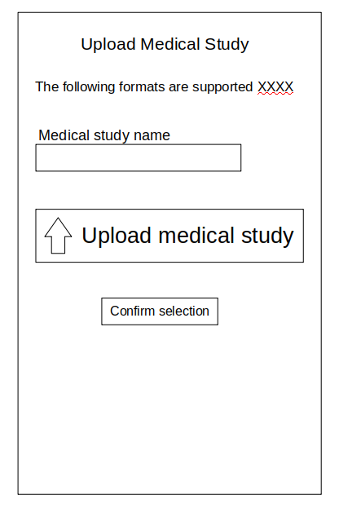

* + 1. **Request to Change Medical Information**

**Brief Description**

This use case allows the patient to send a request to the system to apply a change to his medical information. The patient will be able to track the status of this request.

**Actors**

1. Primary Actor – Patient

* + 1. **Grant Access to the Doctor**

**Brief Description**

This use case allows the patient to grant access to the doctor to view and modify their medical information and/or medical history. The patient is able to view the information of the doctor that accessed their account, and the modifications done by the doctor to their medical information.

**Actors**

1. Primary Actor – Customer Service Representative
   * 1. **Modify Patient’s Medical Information**

**Brief Description**

This use case allows the customer service representative to modify or update the information requested by the patient, so the information shown is correct.

**Actors**

1. Primary Actor – Customer Service Representative
   * 1. **Validate Doctor’s Information**

**Brief Description**

This use case allows the customer service representative to see the requests and the information attached to them from all the doctors. The customer service representative is able to update the status of the request, add feedback or ask for clarification.

**Actors**

1. Primary Actor – Customer Service Representative